India tour 14-30 November 2018
Jaisalmer in Desert
Day 6:- bus to Jaisalmer, located at the far western area of Rajasthan not far from the border with Pakistan, about 320klms from Bikaner and is known as the “Golden City” because the buildings are constructed in yellow sandstone.
Another wake-up call at 6.30am saw Alan all prepared for the day’s travel with his case packed and back-pack items sorted. This is to be a long day’s travel over 320klm’s through mostly arid semi desert country. Breakfast over by 7.30am, room account settled with the front desk at the hotel and on the bus for departure at 8.30am.
During the long drive, thankfully on better quality roads, a stop was made to photograph some wild life. A small antelope type creature about as big as a large dog (see photo). Later another stop to observe a camel herder with his troop of animals waiting on transport to arrive. Alan gave the man a 10Rupee note (20cents) for the privilege of taking his photograph. Harch, the tour guide, said that was generous. The man also wanted a pen which Harch refused saying he would only want to sell it. Also in the remote semi desert there was evidence of brick works operating.
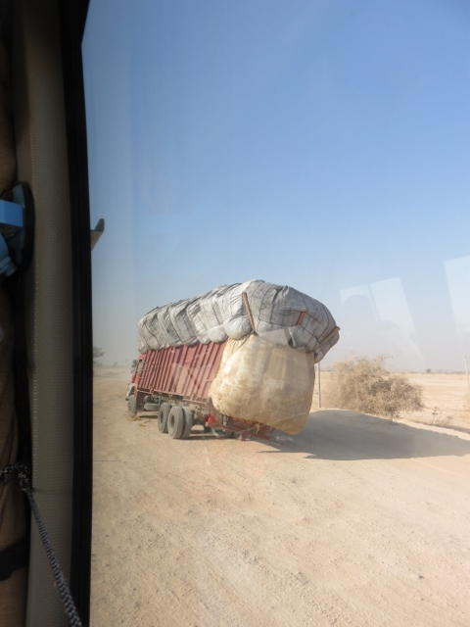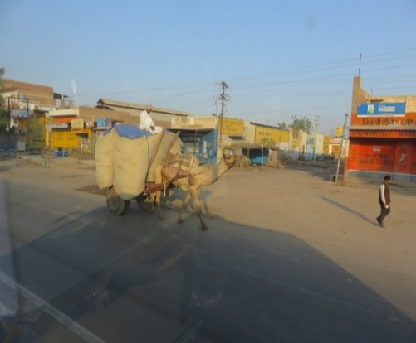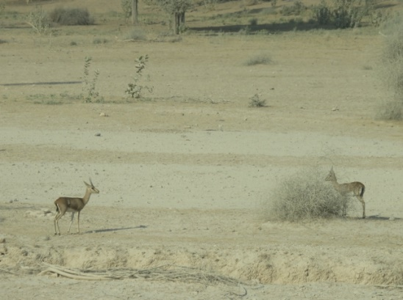
Hazard on road out of Bikaner Camel transport to avoid wild life type of antelope.
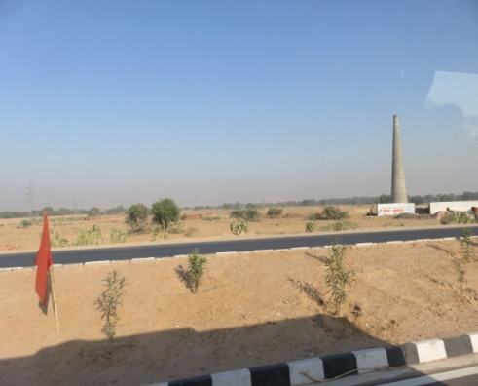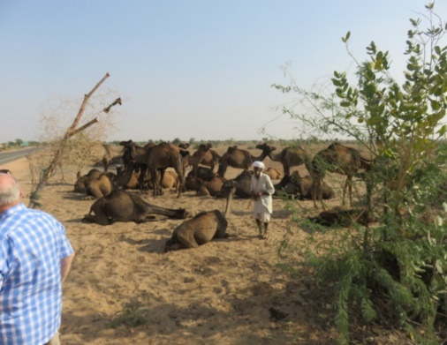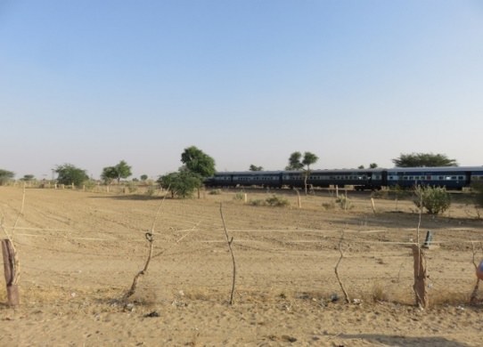
Brick works in desert. Camel herder and his group. That train speeding past level crossing.
Further down the road to Jaisalmer the road came alongside a railway line which apparently was the main rail link back to Delhi. An enormous road work construction site had to be negotiated by the bus. This was to build a ramp and bridge for the road to cross the rail line unhindered. Unfortunately not finished and traffic had to come to a stop for a long passenger train to pass at the level crossing. Lunch was at another specialised wayside establishment set up to feed the tourists in the middle of nowhere.
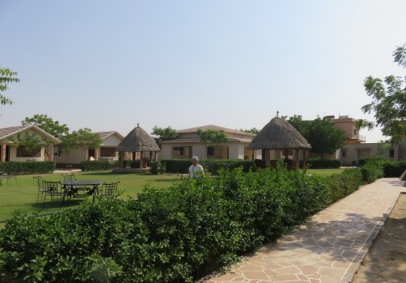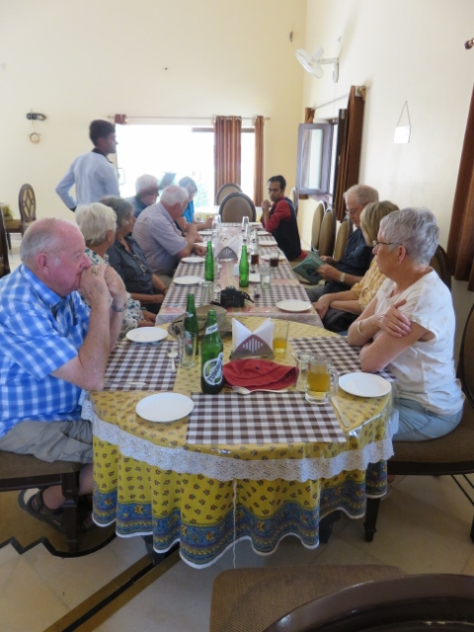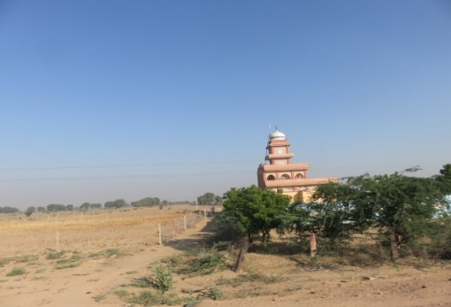
Lunch oasis in semi desert Tour Group at lunch another roadside temple in desert.
Nearby to the lunch stop was a small town where a pit stop was made at a manmade lake that locals had constructed 10 years previously to attract migrating geese from China. The geese have a beautiful soft grey and navy blue colouring. They now come in their thousands as the locals distribute gain to feed them mornings and evenings.
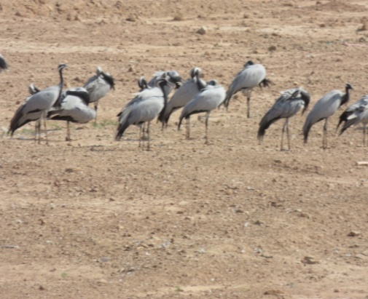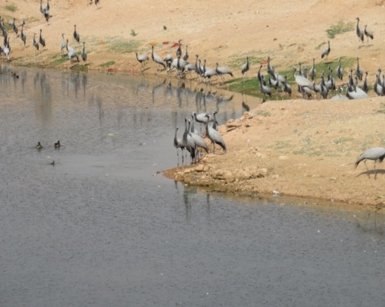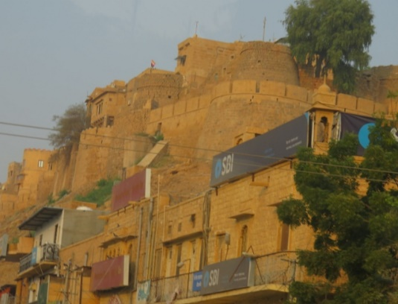
Migratory geese from China manmade lake for them to rest and feed another hill fort on way not visited.
Arrival at Jaisalmer was at 4pm but not directly to the hotel as another establishment beckoned by Harch. This was a small building housing a silversmith and their workshop. An introduction to the method of utilising the raw silver (from a block the size of a cake of soap and surprisingly heavy) to make various items of jewellery and other ornaments. Of course the proverbial sell in the shop area was a given.
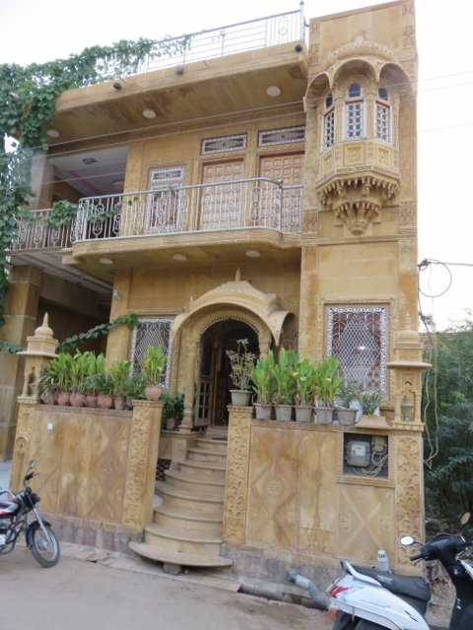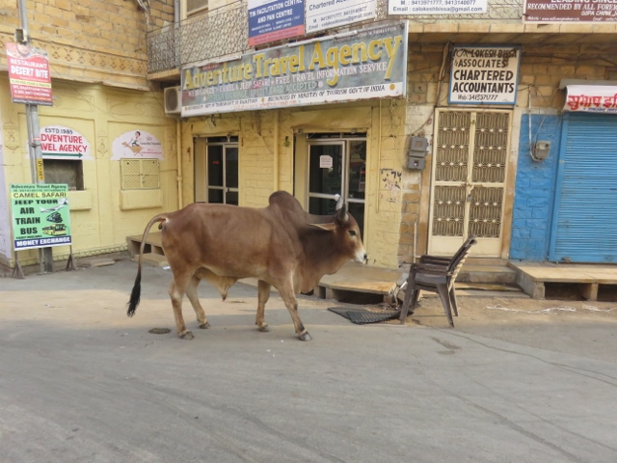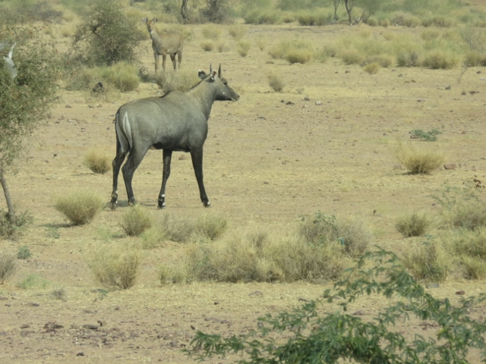
Silversmith’s establishment Road hazards & sign says chartered accountant Blue buck wild life.
Eventually the arrival at the Fort Rajwada hotel was achieved by 6.00pm. Alan was allocated room 116 which was on a second floor about 200 metres down 2 long corridors away from the rest of the tour group. Must have been in the naughty corner. Dinner at 7.30pm was in a large ballroom type room with a central buffet and surrounded by large round tables accommodating 14 persons. (Refer to Jaisalmer hotel pages). There were over 15 different type of food dishes provided, some so hot that slices of cucumber and beetroot were needed to put out the fire! Into bed by 9.30pm.
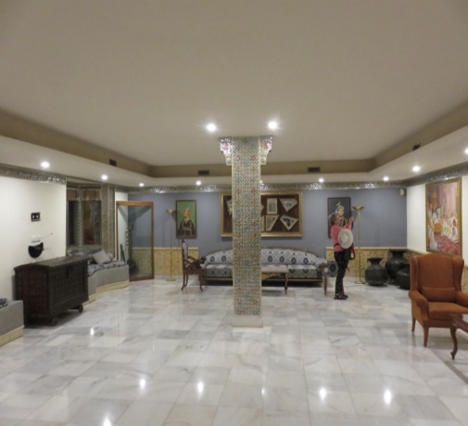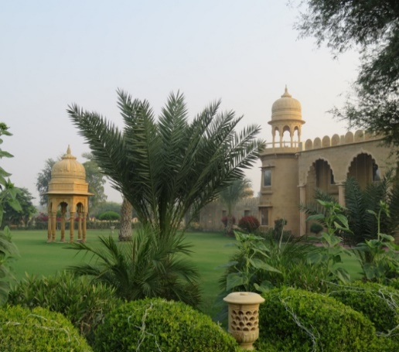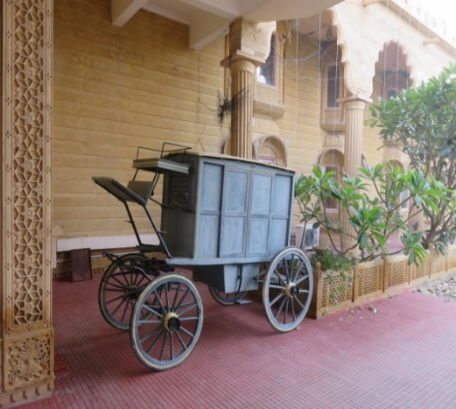
Fort Rajwada hotel lobby area Gardens at front of hotel antique transport on display.

